Research Into Esports – How To Engage The Spectator and The Player

  - By Adam Preece

Contents
Table of Figures 4
Introduction 5
Real Life Sports 5
Real-Life Sports Deconstruction 5
Why Do People Spectate Sport? 6
Partisans, Purists and Passive Fans 6
Partisan 6
Purist 6
Why Do People Play Sport? 7
Why people play 7
Benefits of playing sport 7
Sports and video games 7
The Wow Moment 7
What is a wow moment? 7
Long-term wow moments 7
Short-term wow moments 7
Intensity In Sport 8
Ranked Systems 9
Ranked Systems in Games 9
Ranking In Real Sports 10
Why is there a ranked system? 10
What Is An Esport? 10
Watching Esports 11
Esports Games 11
What enables a game to be an Esport? 12
An Ecosystem 12
Path to Pro 12
Narrative development 12
Live Events 13
Game Design In Esports 13
Play Testing 14
Character Design 14
Core Pillars 14
Depth & Complexity 14
Game Management 14
Having Fun 14
Broadcasting 15
On Screen Elements 15
Commentary 15
Action Replays 16
Conclusion 17
References 18

Table of Figures
Figure 1: Design Pillars 5
Figure 2: Real Sport Design Goals 6
Figure 3: Football Match Intensity Meter 9
Figure 4: Rocket League Rankings 10
Figure 5: Video Game Design Goals 12
Figure 6: Esport Features 12
Figure 7: Identifying Potential For Esports 13
Figure 8:Rocket League Grassroots Community 13
Figure 9:Rocket League Live Event 14
Figure 10: League of Legends Stream UI 16
Figure 11: Football Stream UI 17

Introduction
In this document, there will be a discussion of Electronic Sports (Esports), the overarching question being asked is, ‘How do Esports engage both the spectator and the player?’
Real sports and Esports need both players and spectators to be successful. To explore this question, this document will aim to answer the following.
- What is sport?
- Why do people enjoy spectating sports?
- Why do people enjoy playing sports?
- What is a wow moment?
- How are wow moments created?
- What is an Esport?
- How do Esports compare to real-life sports?
- What does a game’s design need to be eligible for Esport?

Real Life Sports
Sports are defined as an activity involving physical exertion and skill in which an individual or team competes against another or others for entertainment (Collins, 1824).
Here are 5 popular sports that most people will recognise.
Football | Football is by far the most-watched sport in the world (Wood, 2008), the World Cup has over five billion viewers per tournament.
Formula One | Formula One is watched all over the world and is considered the pinnacle of motorsport (Steiner, 2022).
Snooker | Snooker has over 5,000 Professional and Semi-Professional players in the UK, due to it being so widely available and recreational (Jenkins, 2022).
Boxing | Boxing has around 18,000 professional athletes in the world (Lindner, 2023).
Baseball | The Baseball World Series has over fifteen million views (Baker, 2023), which is a large amount considering the series only consists of teams from North America.

These five sports all have a large following, throughout this document these sports are referenced and used in a comparison to Esports.

Real-Life Sports Deconstruction
These five sports can be deconstructed using four different design pillars: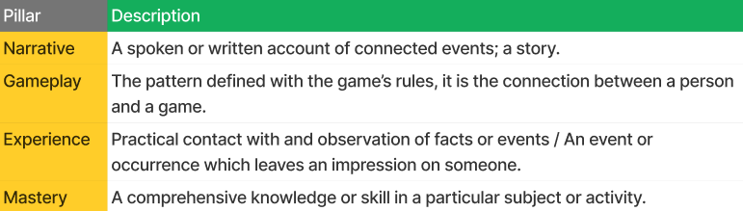
Figure 1: Design Pillars
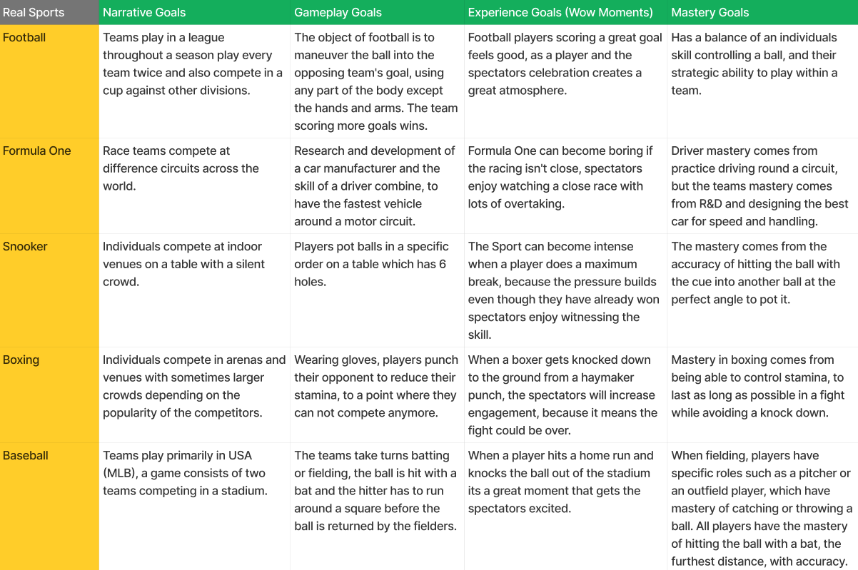
Figure 2: Real Sport Design Goals

Why Do People Spectate Sport?

Partisans, Purists and Passive Fans
To determine why people, enjoy spectating sports, popular sports have many types of fans, most can be placed into two distinct categories.
The Partisan and The Purist. There are also passive fans who don’t care for the sport or the players but will watch it for the social aspect, like drinking in a bar with friends. This document will focus specifically on the Partisans and Purists.

Partisan
A Partisan is probably more familiar to an average person. They support their team religiously and want their team to win, to the point where they will happily accept an ugly victory, to an eventful, exciting loss. They usually engage in aggressive cheering and booing, they interpret a referee’s rulings with a slanted eye, and they feel happy and sad depending on their team’s fortunes (Gaffney, 2013).

Purist
In comparison, the Purist appreciates the complexity and inherent beauty of what they call the sport itself, enjoying the intricate mechanics and game rules that players must adhere to (Gaffney, 2013).
Both types of fans watch sports for a different reason, but in every sport, there are moments that the Partisan enjoys, or the Purist enjoys. However, if you happen to be a passive person who doesn’t care for sports, it creates an exciting social atmosphere.

Why Do People Play Sport?
Humans engage in sports for several reasons.

Why people play
Sports are played as a game or a match, a competitive duel where people compete against each other to see who is better. The primary motive for people taking part in sport is to have fun and enjoyable experiences (Bailey, 2013).

Benefits of playing sport
Playing sports is also considered good for the mind. Whether it is team or individual, it is beneficial for improving mental health (Eather N, 2023)

Sports and video games
Sports are forms of escapism, they can release any anger or frustration a person may have with things that are out of their control (Active Norfolk, 2021). The escape from daily life also applies to people who indulge in playing video games, it can be seen as a form of escapism from reality (Umer Hussain, 2021).
This shows a similarity between people who play sports and people who play video games.
Research shows different reasons for people playing sports. Whether it is a competitive person who wants to be the best in the world at a specific discipline, or just somebody who wants a break from a busy lifestyle to release tension. People’s desire to play sports offer the opportunity for the spectator to watch it and enjoy it. People’s desire to play video games also offers the opportunity for spectators to watch them.

The Wow Moment

What is a wow moment?
A ‘Wow Moment’ refers to that specific point when humans, experience that feeling of thrill, the rush of adrenaline and an increased heart rate that releases endorphins into the body and makes us feel satisfied.
- Wow - You can say 'wow' when you are very impressed, surprised, or pleased (Collins, 1824).
- Moment - You can refer to a very short period of time, for example, a few seconds, as a moment. (Collins, 1824).

Long-term wow moments
Wow moments happen in sports regularly, when a footballer plays his 500th career game at the same club we are impressed, when an underdog fighter wins the world title in boxing, we are surprised or when your favourite baseball team wins the world series you feel pleased. These show wow moments that have a build-up over a long period of time. There are also wow moments that happen on a play-to-play basis.

Short-term wow moments
Wow moments that happen on a play-to-play basis are, for example, when a football player scores a 35-yard free kick, or when a snooker player perfectly stops the ball from rolling and tucks it behind a coloured ball, blocking their opponent’s next shot.
It is these short-term wow moments that allow for the intensity of the game or match to rise and fall. Both the Partisan and the Purist can take joy from these. If we use the example of a fan-favourite football player scoring a curling goal from 30 yards out, the Partisan enjoys their home team scoring what they consider a great goal, from what might be their favourite player, whereas the Purist can respect the skill that it takes and the time it has taken to learn the ability to score that said goal. An example of a wow moment is when David Beckham scored the winning free kick for England against Greece in 2001, to qualify for the World Cup finals (Ryan, 2021). The goal became one of the biggest wow moments ever and is remembered especially by England football fans.
These precise moments show our categories of fans, all enjoying a wow moment together. The passive fan can appreciate the atmosphere and the moment created when everybody in the bar is cheering. However, the wow moment can also be enjoyed by the player themselves, they feel all their hard work and practise paying off, which leads up to that precise moment of skill.
What is most important, is that when the game or sport is created, it must allow for these moments to happen. These moments have an important role in creating fan satisfaction and a varied intensity throughout a game.

Intensity In Sport
Throughout a match or game, whatever the specific sport calls its contests, regardless of which sport is being played, there is always going to be a fluctuation of intensity over time.
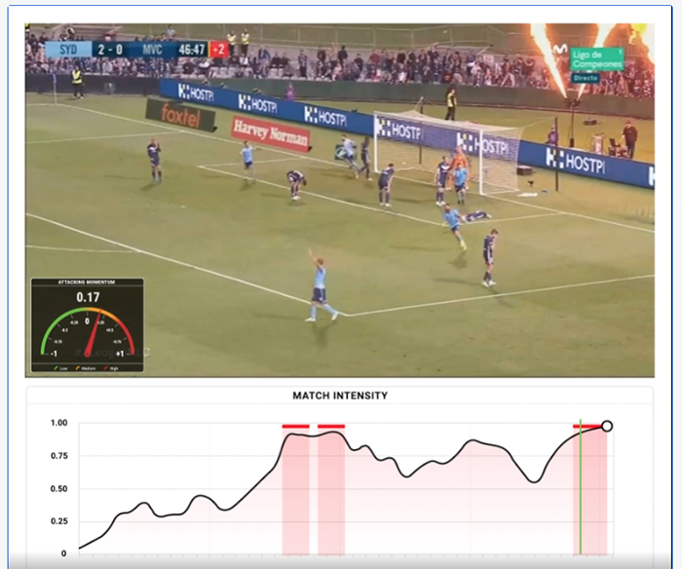
Figure 3: Football Match Intensity Meter
The wow moments in sports are created at the height of the intensity, people enjoy a diverse range of intensity throughout a match because this evokes emotion and passion. The different levels of intensity are what keep the spectator and player engaged. Whether it’s a Football match with one or two goals or a Formula One race with 45 overtakes.
These rises and falls of intensity, are present in video games, for example, when a single- player video game level is designed, the designer needs to ensure that the player stays engaged. Level beats are used to keep the player engrossed, by strategically creating the level with areas of higher and lower intensity (Ellis, 2015).
Players are put into two types of scenarios in video games, one where they are placed against artificial intelligence, this is referred to as Player-versus-Environment (PvE). The other scenario is when players are pitted against one another, either as individuals or teams, these are referred to as Player-versus-Player (PvP). In some cases, the scenarios are combined, where Players are against other players as well as Ai.
In the case of video games designed for PvE, the level beats will be preset for the player to enjoy the experience and not become bored. However, in the case of PvP scenarios, the intensity level will fluctuate based on the ability of the players themselves. For example, if two players of high skill levels compete, the intensity should remain high throughout, because the skill levels, are similar. But if a player of a high skill level competes against a player of a low skill level, the game could become boring due to the better-skilled player beating their opponent easily (Ellis, 2015).
The same can be said for two players of low competency, because their skill levels are evenly matched, the game becomes more watchable for the spectator because the score will stay similar.
Having this fluctuation of intensity is important for both the player and the spectator. It allows the Partisan spectator to enjoy their team go from winning and losing and the hype it creates, the Purist spectator can enjoy the intensity changes, which could be the reason they love the actual game. The player can enjoy the highs and lows of winning and losing because some players are motivated more when losing, whereas some are more motivated when they’re already winning.

Ranked Systems

Ranked Systems in Games
With players having different levels of competency and skill, developers have developed systems to keep players engaged. They have ways of putting similar skill levels against one another.
In PvP games, the developers usually include something called SBMM (Skill-Based Match Making). This is important because it always keeps similarly skilled players together. This is a hidden mechanic in most games, as it is present but isn’t necessarily made obvious to the players.
Another system in a lot of PvP games is a ranking system. Which is a visible system to the players and can be seen by others, as a way of showing your skill level. Rocket League has a ranking system that looks like the following:
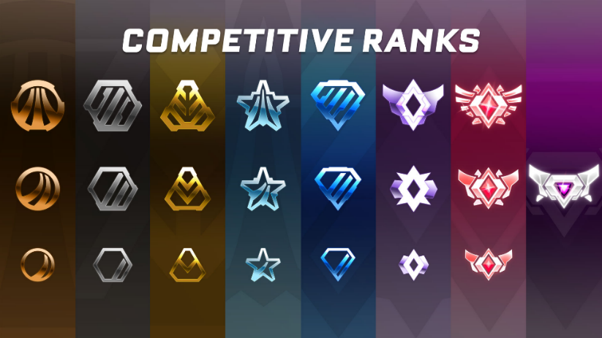
Figure 4: Rocket League Rankings
The left column shows bronze ranks one, two and three. Then it is silver, gold, platinum diamond, champion, grand champion and finally the most prestigious rank, the supersonic legend which has only the top 0.06% of players reaching it (Tracker Network, 2024).
Ranking system are important as when a player competes against another of similar skill, they can maintain their flow state, the state occurs when a player’s attention is captured by the game and they lose all sense of time and space. (Eng, 2024).

Ranking In Real Sports
To compare the Rocket League ranked system to a real-life sport, Football Leagues across England and Wales are similar. They are made up of many divisions, the top 5 divisions teams compete in are:
- Premiership
- Championship
- League 1
- League 2
- National League
There is an extensive list which goes further down, where there are north and south conferences and lower leagues of football. The Premiership is the top tier of football at club level in the country. The Premier League is the most watched league of any sport in the world. ‘The Premier League was shown in a total of 188 of the world's 193 countries recognised by the United Nations’ (premierleague.com, 2019). This is due to the fans enjoying the best football players in the world, battling it out in the title race every season.

Why is there a ranked system?
These ranked systems are important to each sport because they keep players of the same calibre against one another, this prevents higher skill levels easily defeating players or teams of a lower skill level.
The system keeps players engaged because they stay in their flow, they don’t become bored or frustrated. The system keeps spectators engaged because the games or matches are not one-sided where one team or player maintains dominance over their opponent.

What Is An Esport?
The authors define Electronic Sports (Esports) as “a form of sports where the primary aspects of the sport are facilitated by electronic systems; the input of players and teams as well as the output of the Esports system are mediated by human-computer interfaces.” (Hamari. Juho, 2017)

Watching Esports
Spectating Esports can be seen as a similar activity to spectating any real-life sport. Most commonly, Esports are watched on live streams on the internet, where as well as watching the event, spectators can be involved in digital social interaction, usually in the form of chat features (Hamari. Juho, 2017). During the 2020 Covid pandemic, Esports were widely watched even more so because they were the only form of sport that people still could spectate (Project11.tv, 2020).

Esports Games
There is a plethora of Esports games out there, and the Esports industry is a growing one, surpassing the 1-billion-dollar mark in 2019 (CNBC International, 2019). Some examples of Esports games are:
- League Of Legends (Riot Games, 2009) | The most-watched game in the history of Esports, peaking at 6.5 million watchers in 2023 (EsportsCharts, 2024).
- Rocket League (Psyonix, 2015) | Has had a prize pool of over $31 million and has peak viewers at over 460k (EsportsCharts, 2024).
- Street Fighter (Capcom, 1987) | Has had a prize pool of over $6.5 million and has peak viewers at over 440k.
- Apex Legends (Respawn, 2019) | Has had a prize pool of over $22.5 million and has had peak viewers at over 700k.
- Valorant  (Riot Games, 2020) | Valorant which is the most recent release on this list has had a prize pool of over $26 million and has peaked viewers at over 1.5 million.

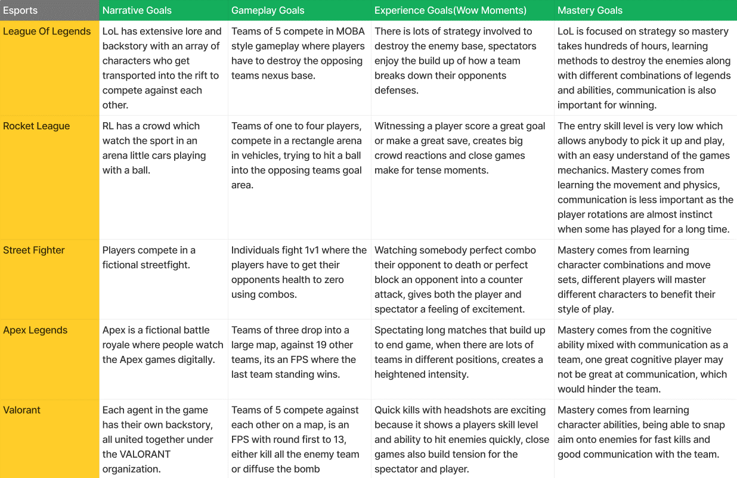
Figure 5: Video Game Design Goals

What enables a game to be an Esport?
Some important features stated by Nick Allen (CEO, Twitch) that a game needs to be identified as a potential Esport are:
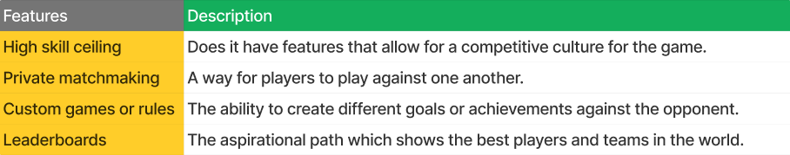
Figure 6: Esport Features
All these points relate to the game having a competitive culture, which Rocket League does extremely well (Allen, 2017).
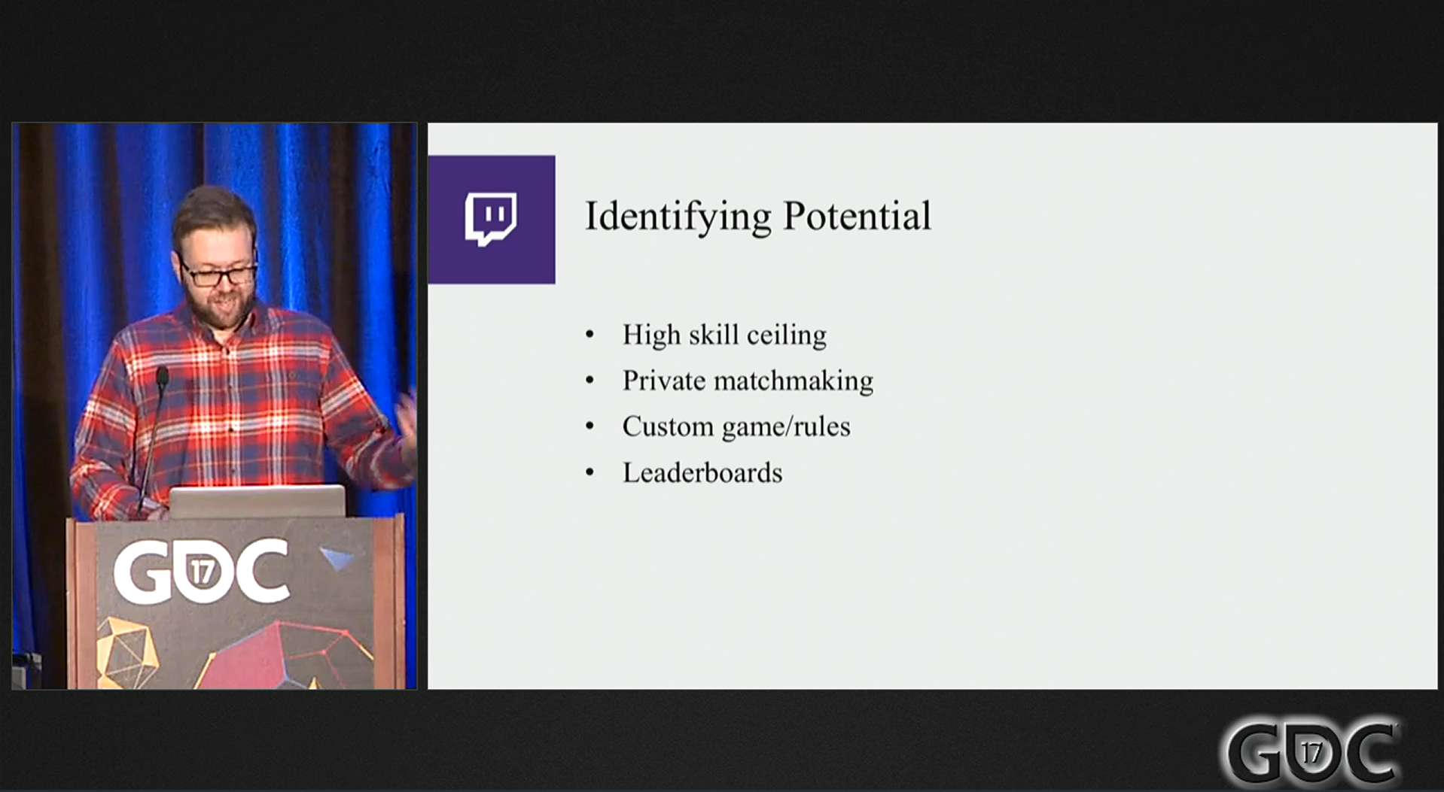
Figure 7: Identifying Potential For Esports

An Ecosystem
An Esport needs to have a wholistic ecosystem for it to be successful, The Rocket League Championship Series (RLCS), represents the top level of players in the world.

Path to Pro
The ecosystem must enable the players to have a path to pro (Allen, 2017). In Football, children play through primary school, then through high school, and then they may join a young players academy, which is aimed at finding the best talent in young players to develop them into the pro leagues. Esports games must have a similar system, they must have a pathway for people to make it to the top level. They enable this by having local qualifiers, that give every person who wants to play competitively, the opportunity to do so.

Narrative development
Esports also need a way for the spectator to follow their favourite players or teams. Just like real sports, the Partisan wants to support a player or team. Whether it’s the team which comes from the same city or country as them, or they can enjoy the charisma and enthusiasm of a certain player. Esports use interviews with pro players to give the fans a way of feeling like they know that person. The high charisma of a player who also has a very high skill level will generally gain a following from the fans as they will enjoy that individual both in and out of the game.

Live Events
Live events are designed for the spectators to get up close and personal with the game they enjoy watching. The organisers will hire out an arena or similar and fans can buy tickets to go and watch the event happen right in front of them. This creates an atmosphere which adds to the wow moments, which in turn enables cheering and booing from a crowd of supporters.
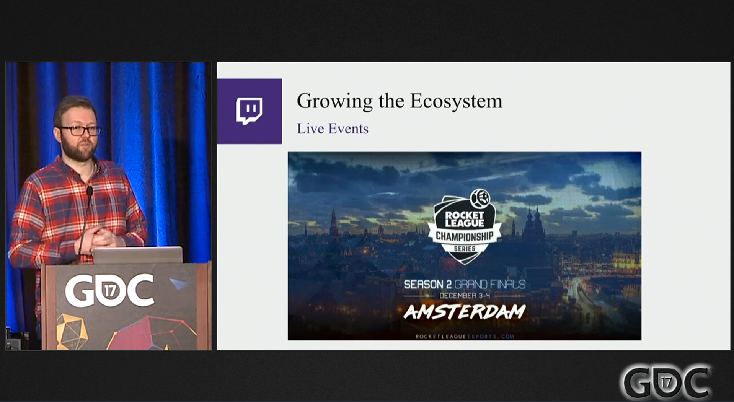
Figure 9:Rocket League Live Event
All of these factors are important to both the player and the spectator, the path to pro gives the casual player a chance to potentially become a pro given the opportunity, the narrative development gives players a chance to express themselves during interviews and gives ‘fan service’ which spectators will enjoy. The live events allow the spectators to get up close and personal with their favourite game or favourite players depending on if they are Partisan or Purist.

Game Design In Esports
The most played Esport in the world is League of Legends (LoL), however, it is a very complex game to learn. It has been described as Chess, plus Basketball, plus Pokémon. It is Chess-like because it is a strategy game, with choices, tactics and decision-making. It is like Basketball due to a high skill ceiling and you are in a team of five, it is about calling plays, executing plays and having good communication skills with your team. It is like Pokémon because it is elaborate and complicated, it requires a lot of knowledge and memory about all of the different characters, their abilities and all of the items which can be used within the game (Ryan Scott, 2015).

Play Testing
The design team play-test LoL twice-a-day so that they always maintain balance in their gameplay, playtesting is an important part of game development as it allows the designers to find bugs or imbalances in characters’ abilities which make the game unfair.

Character Design
When new characters are created to fit into the game, they are designed with a certain purpose and a goal. The development team will strategically plan a design process for a character with an idea of how the players and the fans will react to them (Ryan Scott, 2015).

Core Pillars
One of the core pillars of LoL is that it requires player mastery, if a game is built to be broadly appealing first with a low level of mastery, then after some time, make the gameplay deeper, you will fail because you’re building on a weak foundation. If you build a game that has a deep learning curve and lets you master things over thousands of hours, that is a successful recipe for a game to last in the eSports industry (Ryan Scott, 2015).

Depth & Complexity
When creating depth in gameplay it is important not to overcomplicate it, for example, if a new game mechanic is introduced it needs to be simple so that players can understand it but also have meaning so that it changes the dynamic of the game. If mechanics are overly complex the players will become frustrated and not enjoy their experience, which will put them off learning further mechanics. A best practice in design is to have the least complexity in a mechanic to get the most depth.

Game Management
With every sport and every player or team, there is a manager or coach. In League of Legends, the player acts as a manager of little minions that spawn every 30 seconds, the minions are spawned and they walk down their designated lanes to attack the enemies, these are important to controlling the map. This micro-management is an example of a simple non-complex mechanic which adds a lot of depth but gives the player strategic decisions to make, which can win or lose the match.

Having Fun
The hardest part of creating a well-balanced game is creating a game that is also fun.
Fun - You refer to an activity or situation as fun if you think it is pleasant and enjoyable and it causes you to feel happy (Collins, 1824).
We have established that people enjoy wow moments in games, these are what the players and the spectators both enjoy, so when designing new characters with new abilities, they may be designed to have an overpowered ultimate ability which people enjoy seeing take place, but then this would need balancing in other areas, for example, a longer cooldown or lesser powered regular abilities. Some abilities might be combined with specific items or other characters’ abilities to create further wow moments, these moments can severely impact the outcome of a match.
Keeping a game fun, as well as balanced, is a key part of creating a game that is enjoyable for both the spectator and the player. The playtesting allows the development team to perfect the balance.

Broadcasting

On Screen Elements
The development team work closely with the broadcasting team for League of Legends to make sure the spectator has just as good an experience as the player. Important aspects are the visual hierarchy, what is available on the screen to the spectator. When watching Football, the spectator can always see the score and the timer in the corner of the screen. This is key information and the broadcast team needs specific displays of metrics that are always active on screen.
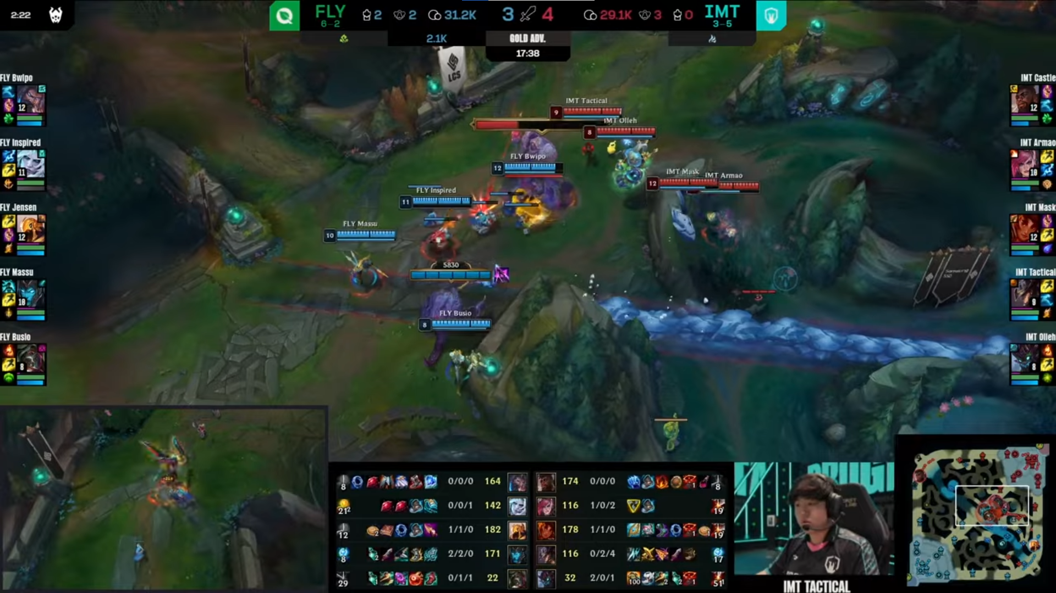
Figure 10: League of Legends Stream UI
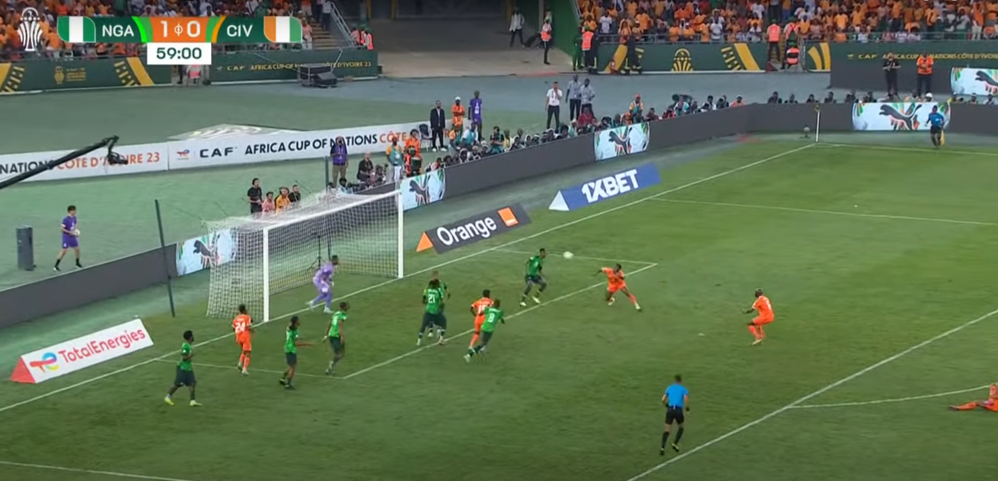
Figure 11: Football Stream UI

Commentary
The commentary teams also add to the enjoyment for the spectator, they are usually experts and have in-depth knowledge of the game that’s being played, the best commentators are usually full of passion and enthusiasm when it comes to the wow moments. They often have catchphrases that they use for certain wow moments. For example, the start of every Formula One race is exciting as the cars dash to make it to the first corner first. Murray Walker had the famous catchphrase ‘Lights out, and its go go go…’. He became synonymous with this phrase as he said it full of enthusiasm.
Commentators can also help newer spectators to understand the mechanics of a game or sport due to their knowledge, they can explain what’s happening.

Action Replays
Every sport that is shown in digital format, for example, on TV or a live stream service, can show a replay of a wow moment. When a Football player scores a goal, it is shown again from multiple angles so the spectators can appreciate the goal even more.
Broadcasting with good commentary is beneficial to the spectator as it improves their experience of watching, having good on-screen User Interface helps the spectator to understand what is going on at a glance. The action replays give the spectators a chance to watch back a moment of excitement which they found pleasure in seeing. All these elements are important for the spectator to remain engaged.

Conclusion
This document was intended to discover how Esports engage both the spectator and the player. By comparing Esports to real-life sports, they both consist of players and spectators, this allows successful real-life sports to give insight into what could make an engaging Esport. Real-life sports have a high skill ceiling, people will spend a lifetime to become a Professional, therefore, an Esport must also have a high skill ceiling. It is important that mastery is embedded in the games core pillars, regardless of its entry-level skill.
Looking through the lens of the Spectator, there is a broad spectrum, research shows most fans can be placed in the category of Purists and Partisans. They both watch sports for different reasons, the Partisans who follow their team to victory and the Purists who love the sport itself. Both categories enjoy witnessing the ‘wow moment’, which usually depicts a player’s level of mastery at its peak. When designing a game, it must contain mechanics to enable these moments, they have importance in creating spectator satisfaction and varied intensity. The intensity fluctuation keeps both the player and the spectator engaged. A ranking system is also beneficial for keeping spectators engaged, it enables similarly skilled opponents competing together, so games are not one-sided, leading to boredom. Broadcasting with knowledgeable commentary enhances the spectators experience, having a good on-screen User Interface helps the spectator understand what is going on. Action replays give spectators the chance to watch back a wow moment, depicting a player at the peak of mastery.
Looking through the lens of a Game Developer. A game will benefit from an ecosystem, narratives and live events, which all help to engage both the player and the spectator. The ecosystem gives casual player’s the chance to become Pro and the spectator to witness their journey. The narrative gives players a chance to express themselves, this is important to a Partisan, as it gives them opportunity to see their favourite players talk about their experience. Live events allow both categories of spectators to get up close and personal with their favourite game or favourite players.
Looking through the lens of the Player, a ranking system keeps players engaged because they play against similarly skilled opponents, this enables them to they stay in their flow. The player also needs a high skill ceiling. The player must have the ability to show their skill, by enabling wow moments in a games design this can be accomplished. The core pillar of mastery is prevalent throughout all game’s in Esports.

References
Active Norfolk, 2021. The Mental Benefits Of Sport. [Online]
Available at: https://www.activenorfolk.org/2021/05/mental-benefits-of-sport/
[Accessed 12 02 2024].
Allen, N., 2017. eSports Day: Building eSports: Twitch, 'Rocket League'. s.l., GDCVault.
Baker, A., 2023. the most watched sporting events in the world. [Online]
Available at: https://www.roadtrips.com/blog/the-most-watched-sporting-events-in-the-world/
[Accessed 08 02 2024].
Bellis, M., 2019. A Brief History Of Sports. [Online]
Available at: https://www.thoughtco.com/history-of-sports-1992447
[Accessed 12 02 2024].
Blum, B., 2018. E-Sports In Depth, s.l.: GDC Vault.
Brad Stenner, J. B. A. M., 2019. Reasons why older adults play sports: A systematic review. J Sport Health Sci, 9(6), pp. 530-541.
Capcom, 1987. Street Fighter. s.l.:Capcom.
Carter, K., 2023. runnersworld.com. [Online]
Available at: https://www.runnersworld.com/uk/training/beginners/a772514/how-often-should-you-run/
[Accessed 16 02 2024].
CNBC International, 2019. Esports is growing into a $1 billion industry | CNBC Sports, Hong Kong: CNBC.
Collins, 1824. Collins Dictionary. s.l.:Collins.
Deci, E. R. R., 1987. The support of autonomy and the control of behavior. Journal of Personality and Social Psychology, Volume 53, pp. 1024-1037.
Deci, E. R. R., 2000. The "What" and "Why" of Goal Pursuits: Human Needs and the Self-Determination of Behavior. Psychological Inquiry, Volume 11:4, pp. 227-268.
Eather N, W. L. P. A. E. R., 2023. The impact of sports participation on mental health and social outcomes in adults: a systematic review and the 'Mental Health through Sport' conceptual model.. National Library Of Medicine, Volume 12.
Ellis, P., 2015. Single Player Level Design Pacing and Gameplay Beats. World Of Level Design, Volume 1, p. 3.
EsportsCharts, 2024. escharts. [Online]
Available at: https://escharts.com/top-games?year=all-time&order=peak
[Accessed 06 02 2024].
Gaffney, P., 2013. Watching Sport: Aesthetics, Ethics and Emotions. Journal Of The Philosophy Of Sport, 40(1), pp. 180-184.
Hamari. J, S. M., 2017. What is eSports and why do people watch it?. Emereld insight, 27(2).
Hamari. Juho, S. M., 2017. What is eSports and why do people watch it?. Emerald Insight, 27(2), pp. 211-232.
Jenkins, S., 2022. What makes snooker such a popular sport?. [Online]
Available at: https://www.feast-magazine.co.uk/activities/sports-leisure/what-make-snooker-such-a-popular-sport-33473
[Accessed 08 02 24].
Lindner, J., 2023. must-know boxing statistics. [Online]
Available at: https://gitnux.org/boxing-statistics/#:~:text=According%20to%20World%20Boxing%20News,the%20United%20States%20is%20%2451%2C370.
[Accessed 08 02 2024].
premierleague.com, 2019. premier league. [Online]
Available at: https://www.premierleague.com/news/1280062
[Accessed 10 02 2024].
Project11.tv, 2020. p11.tv. [Online]
Available at: https://p11.tv/traditional-sports-turning-to-esports-during-covid-19-lockdown/
[Accessed 18 02 24].
Psyonix, 2015. Rocket League. s.l.:Psyonix.
Respawn, 2019. Apex Legends. s.l.:EA.
Riot Games, 2009. League Of Legends. s.l.:Riot Games.
Riot Games, 2020. Valorant. s.l.:Riot Games.
RulesOfSport.com, 2022. Rules Of Sport. [Online]
Available at: https://www.rulesofsport.com/sports/snooker.html
[Accessed 16 02 2024].
Ryan Scott, F. L., 2015. Building a Sport: The Design Philosophy of League of Legends. San Francisco, GDCVault.
Ryan, D., 2021. GiveMeSport.com. [Online]
Available at: https://www.givemesport.com/1666444-beckham-freekick-vs-greece-england-wouldve-won-the-world-cup-had-he-missed/
[Accessed 16 02 2024].
Sazon, F., 2021. Game Design & Development 2021. 1 ed. s.l.:s.n.
Schell, J., 2020. The Art Of Game Design. 3rd ed. Boca Raton: CRC Press/Taylor & Francis Group.
Steiner, S. A. T. D. G., 2022. F1 the pinnacle. 1 ed. s.l.:Tony Dodgins.
Tracker Network, 2024. rocket league tracker. [Online]
Available at: https://rocketleague.tracker.network/rocket-league/distribution
[Accessed 10 02 2024].
Umer Hussain, S. J. G. B. C. J. A. M., 2021. The dual nature of escapism in video gaming: A meta-analytic approach. DOAJ, Volume 3, p. 100081.
Valve, 2013. Dota 2. s.l.:Valve.
Wood, R., 2008. Most popular sports list combined. [Online]
Available at: https://www.topendsports.com/world/lists/popular-sport/analysis.htm
[Accessed 08 02 2024].

